* Scaling up apps and services manually from the portal.
* Free Plan does not have Scaling Options.
* 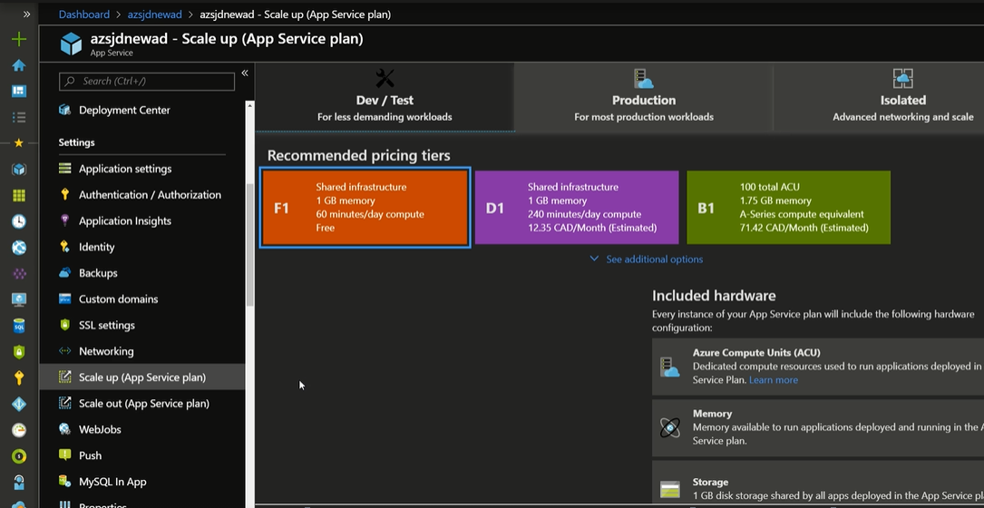
* <https://docs.microsoft.com/en-us/azure/app-service/manage-scale-up>
* Application will spin up B1 instances when we choose the required category.